Basic Body Measurements
1. Bust Circumference: | 4. Sleeve Length:
2. Shirt Waist Circumference: | 5. Shirt Length:
3. Hips Circumference: | 6. Trouser / Shalwar / Lehenga Length:
 | 7. Height:
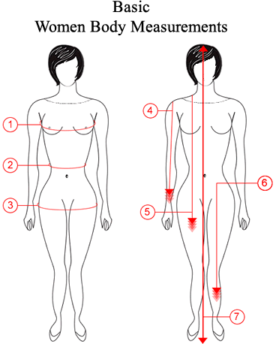
Optional Measurements
Top: | Bottom:
8. Neck Circumference:(Optional): | 20. Trouser Waist Circumference:(Optional):
9. Front Neck Depth: | 21. Crotch:(Optional):
10. Back Neck Depth: | 22. Thigh Circumference:(Optional):
11. Cross Shoulder:(Optional): | 23. Knee Circumference:(Optional):
12. Armhole:(Optional): | 24. Calf Circumference:(Optional):
13. Bicep:(Optional): | 25. Trouser Inseam:(Optional):
14. Wrist Circumference:(Optional): | 26. Trouser Waist to Knee:(Optional):
15. Neck to Bust Point:(Optional): | 27. Trouser Cuffs Circumference:(Optional):
16. Bust Point to Bust Point:(Optional): | 28. Ankle:(Optional):
17. Head Circumference:(Optional): | 29. Weight:(Optional):
18. Across Front:(Optional):
19. Across Back:(Optional):
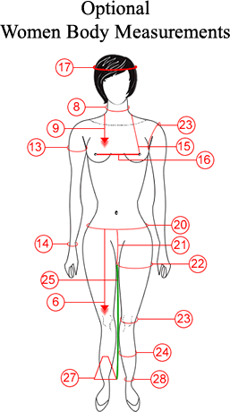
Additional comments, if any:

For help please contact us on +1(862)2180556 (Phone/WhatsApp)

