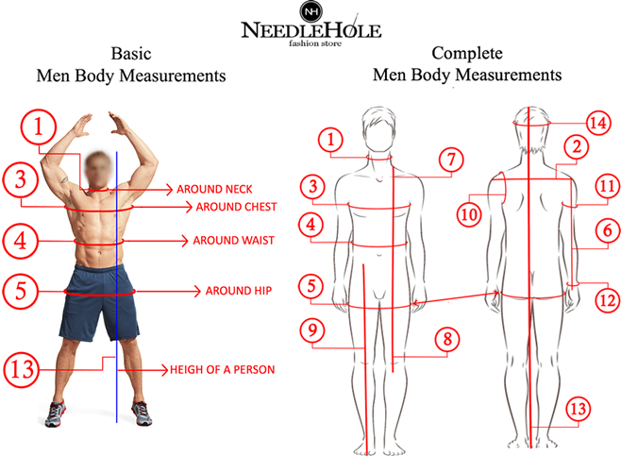

All we need is all around measure of your
1. around neck, 3. around chest, 4. around waist and 13. Height of a person
Body Measurements:
1. Around Neck: 0  2. Shoulder: 0  3. Around Chest: 0  4. Around Waist: 0  5. Around Hip: 0  6. Sleeve Length: 0 (Kurta)  6. Sleeve Length: 0 (Sherwani)  7. Sherwani Length: 0 | 8. Kurta Length: 0  9. Shalwar Length: 0  10. Armhole (optional): 0  11. Biceps (optional): 0  12. Around Wrist (optional): 0  13. Height of a person: inches/centimetres  14. Head Size: 0  15. Shoe Size (optional): 0

When you provide us the exact body measurements, our designers add extra 5 to 6 inches’ room for the kurta shalwar and add extra 3 inches’ room for the sherwani & waistcoat, in the provided exact body measurements (Chest, Waist and Hip) to make it comfortable fit as shown in the picture.

When you provide us the garment/dress size or you select any size from or clothing size chart then we do not add any extra inches and make it exactly as per the garment or dress size or clothing size chart

